SQL assignment -6

1. Write two different queries that would produce all orders taken on October 3rd or 4 th, 1990.

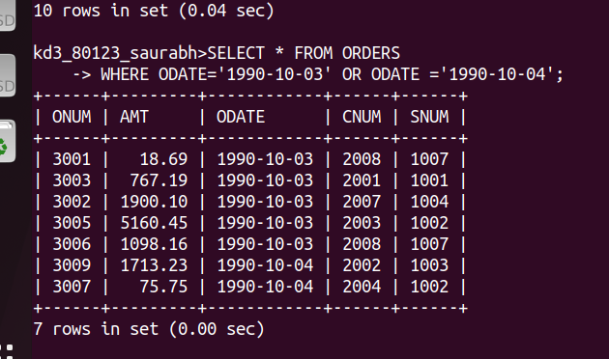
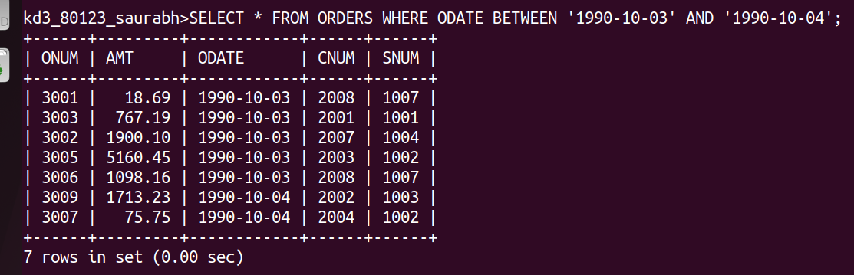

2. Write a query that selects all of the customer serviced by peel or motika.

Ans;
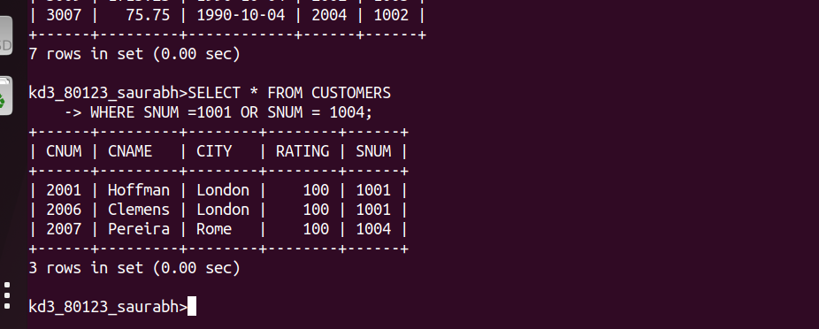

3. Write A QUERY THAt will produce all the customers whose names begin with a letter from ‘A’ to ‘G’;

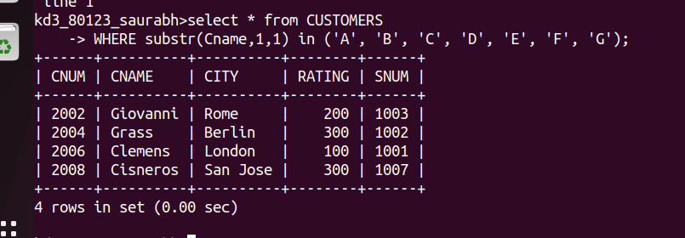
6

4. Write a query that selects all customers whose names begin with the letter ‘C’;
ANS;
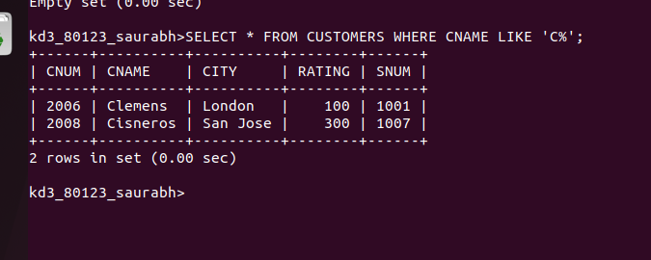

5) Write a query that selects all orders orders except those with zeroes or NULLs in the amt field
ans;
